Life on Land

Introduction to Goal 15 - Life on Land

Use this guide to introduce Global Goal 15, Life on Land to your students.
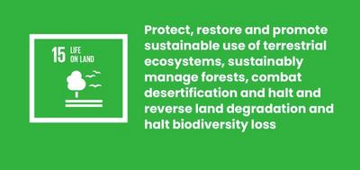

What is Global Goal 15?
Sustainable Development Goal 15: Life on Land is one of the 17 Sustainable Development Goals established by the United Nations in 2015. You can find out more about the SDGs in our introductory guide.
It aims to protect and restore all life on land. This includes protecting ecosystems like forests and rivers, stopping ‘desertification’ caused by droughts, and preventing the loss of plant and animal species, known as ‘biodiversity’.
In the past 50 years 60% of all wildlife has been lost. This is a threat to all of us. But together we can find ways to protect and restore life on land. There are already some brilliant solutions out there, but we need more.

Активности
Below are some ideas to help bring Goal 15 to life for your students. Активности су индивидуалне или представљају низ активностиву оквиру једне лекције.

Activity 1: Protect and Restore Nature

In this activity, students will discuss nature and what they know already about its importance.
Дужина трајања - 10 минута
Watch this video with your class.
https://www.youtube.com/watch?v=US58f-SwO0k
After you’ve watched, discuss:
- How do you feel about nature?
- Did you see anything you already know about?
- Why is nature and biodiversity so important?
- What does nature look like in your community?
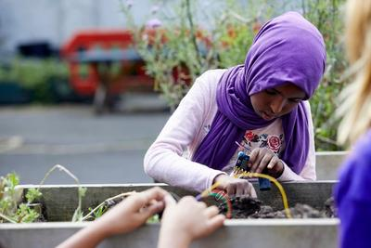

Activity 2: Threats to Nature

In this activity students will think about the threats to nature, locally and globally.
Дужина трајања - 10 минута
In this activity you will ask students to brainstorm a big list of all the threats nature faces - focussing on life on land, so everything apart from our oceans (covered in Goal 14: Life Under Water).
- Ask students: What are the threats currently facing the natural world? Students can discuss and brainstorm different ideas in small groups, listing as many threats as possible.
- Answers could relate to: Forest fires; Animals being poached; Destruction of habitats; Deforestation; Destruction and pollution of lakes and rivers; Soil losing its nutrients.
- Come back together as a group and discuss all the ideas the groups came up with.
- Spend a couple of minutes thinking about which of these problems nature faces in your local community / country.
- Now discuss which problems could be local to other parts of the world and why.
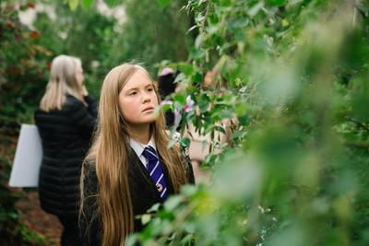

Activity 3: Why Nature Matters

In this activity, students will discuss why nature is so important to people, the planet, and all of the Global Goals.
Дужина трајања - 15 минута

Увод
- Ask students: What do all people need to survive?
- Answers could include clean water, food & medicine.
- Differentiate between things you need (e.g. clean air to breathe), and things you want (e.g. a new pair of trainers).
- Next ask students: Where do these resources come from? Originally they all come from the natural world. Think about all the things the natural world provides for us, from air and food to raw materials for medicine, clothes and construction.

Goal 15 and the Global Goals
Now you have discussed the human behaviours impacting nature, it’s time to look at why this is such a problem for people, planet and the achievement of the Global Goals.
Download the Global Goals grid. On your grid, start by identifying Goal 15: Life on Land. On their own or in small groups, students should discuss which other Global Goals relate to Goal 15. For example:
- Goal 13: Climate Action | Forests absorb CO2, helping to regulate our climate.
- Goal 14: Life Below Water | If rivers are polluted by plastic and sewage they will carry it out into the ocean where it harms marine life.
- Goal 6: Clean Water and Sanitation | We rely on rivers and lakes to provide us with water to drink.
- Goal 2: Zero Hunger | Nature is the source of our food, but we are often destroying nature to make way for bigger farms.
- Goal 11: Sustainable Cities and Communities | For our cities to be sustainable we need to make sure the materials and energy we use are renewable.

Повратна информација
- When the students have finished, ask some of them to share their reflections.
- Did they find any surprising connections?
- How important do they think it is that we protect Life on Land? Why?

