crwdns337471:0crwdne337471:0

crwdns337231:0crwdne337231:0

crwdns337233:0crwdne337233:0

crwdns337237:0crwdne337237:0
crwdns337239:0crwdne337239:0 crwdns337241:0crwdne337241:0
crwdns337243:0crwdne337243:0 crwdns337245:0crwdne337245:0 crwdns337247:0crwdne337247:0 crwdns337249:0crwdne337249:0

crwdns337251:0crwdne337251:0
crwdns337253:0crwdne337253:0 crwdns337255:0crwdne337255:0

crwdns337257:0crwdne337257:0

crwdns337259:0crwdne337259:0
crwdns337261:0crwdne337261:0
crwdns337263:0crwdne337263:0
https://www.youtube.com/watch?v=fE9dYM-P_l0

crwdns337265:0crwdne337265:0
- crwdns337267:0crwdne337267:0
  - crwdns337269:0crwdne337269:0
  - crwdns337271:0crwdne337271:0
  - crwdns337273:0crwdne337273:0

crwdns337275:0crwdne337275:0
- crwdns337277:0crwdne337277:0
- crwdns337279:0crwdne337279:0 crwdns337281:0crwdne337281:0
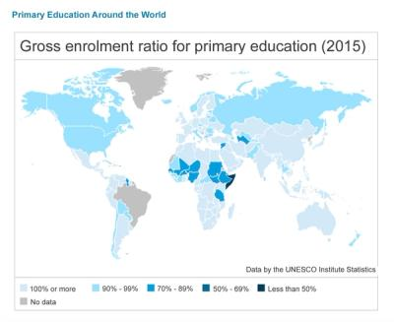

crwdns337291:0crwdne337291:0
- crwdns337293:0crwdne337293:0
  - crwdns337295:0crwdne337295:0
  - crwdns337297:0crwdne337297:0
  - crwdns337299:0crwdne337299:0
  - crwdns337301:0crwdne337301:0 crwdns337303:0crwdne337303:0
  - crwdns337305:0crwdne337305:0
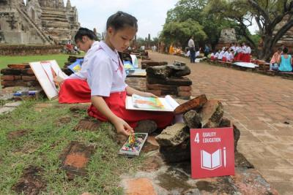

crwdns337313:0crwdne337313:0

crwdns337315:0crwdne337315:0
crwdns337317:0crwdne337317:0

crwdns337319:0crwdne337319:0
crwdns337321:0crwdne337321:0 crwdns337323:0crwdne337323:0
crwdns337325:0crwdne337325:0
- crwdns337327:0crwdne337327:0
- crwdns337329:0crwdne337329:0
- crwdns337331:0crwdne337331:0
- crwdns337333:0crwdne337333:0
- crwdns337335:0crwdne337335:0
- crwdns337337:0crwdne337337:0
  - crwdns337339:0crwdne337339:0
  - crwdns337341:0crwdne337341:0
  - crwdns337343:0crwdne337343:0

crwdns337345:0crwdne337345:0
- crwdns337347:0crwdne337347:0
- crwdns337349:0crwdne337349:0 crwdns337351:0crwdne337351:0
  - crwdns337353:0crwdne337353:0
  - crwdns337355:0crwdne337355:0
  - crwdns337357:0crwdne337357:0
crwdns337359:0crwdne337359:0 crwdns337361:0crwdne337361:0
crwdns337363:0crwdne337363:0
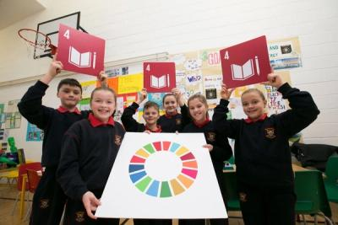

crwdns337369:0crwdne337369:0

crwdns337371:0crwdne337371:0
crwdns337373:0crwdne337373:0

crwdns337375:0crwdne337375:0
- crwdns337377:0crwdne337377:0
  - crwdns337379:0crwdne337379:0
  - crwdns337381:0crwdne337381:0
  - crwdns337383:0crwdne337383:0 crwdns337385:0crwdne337385:0
  - crwdns337387:0crwdne337387:0 crwdns337389:0crwdne337389:0

crwdns337391:0crwdne337391:0
crwdns337393:0crwdne337393:0
- crwdns337395:0crwdne337395:0
  - crwdns337397:0crwdne337397:0
  - crwdns337399:0crwdne337399:0
  - crwdns337401:0crwdne337401:0
- crwdns337403:0crwdne337403:0
- crwdns337405:0crwdne337405:0
crwdns337407:0crwdne337407:0
crwdns337409:0crwdne337409:0
crwdns337411:0crwdne337411:0
- crwdns337413:0crwdne337413:0
  - crwdns337415:0crwdne337415:0
  - crwdns337417:0crwdne337417:0
  - crwdns337419:0crwdne337419:0
crwdns337421:0crwdne337421:0
- crwdns337423:0crwdne337423:0 crwdns337425:0crwdne337425:0 crwdns337427:0crwdne337427:0
- crwdns337429:0crwdne337429:0
  - crwdns337431:0crwdne337431:0
  - crwdns337433:0crwdne337433:0

crwdns337435:0crwdne337435:0
crwdns337437:0crwdne337437:0 crwdns337439:0crwdne337439:0
crwdns337441:0crwdne337441:0
- crwdns337443:0crwdne337443:0
- crwdns337445:0crwdne337445:0
crwdns337447:0crwdne337447:0
- crwdns337449:0crwdne337449:0
  - crwdns337451:0crwdne337451:0
  - crwdns337453:0crwdne337453:0
  - crwdns337455:0crwdne337455:0 crwdns337457:0crwdne337457:0
crwdns337459:0crwdne337459:0
