Introducing the Global Goals

Introducing the Global Goals

Use this guide to introduce the Global Goals to your students.
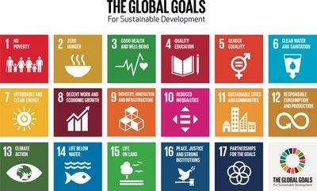

What are the Global Goals?
The Global Goals are a call for action by all countries to promote prosperity for everyone while protecting the planet.
The Sustainable Development Goals (SDGs) or Global Goals are a collection of 17 interlinked goals with actions agreed by all 193 member countries of the United Nations in 2015.
It is the most ambitious international agreement ever made, to eradicate poverty and inequality, protect health and prevent climate change.

Introductory video
This short film addresses why we need the Global Goals and what they are. Show your students this video, then try one of the activities below.
The animation, introduced by Malala Yousafzai and written by Sir Ken Robinson, is a great way to introduce the Global Goals.
https://www.youtube.com/watch?v=cBxN9E5f7pc

Activity 1: Global Goals superpower!

In this activity students will explore how they could achieve the Goals if they could do anything.
Age 8-11, length - 30 mins
Use whole group discussion and small group work to explore the Goals, understand why they exist, learn about some of the impacts and challenges and use the concept of super powers to explore how ideas for solutions can contribute to positive change.

1. Group discussion
- Introduce why we have the Goals: what, who and why using the Introduction to the Goals video.
- Present some examples of the impact that a Goal challenge presents to the people of the world and how it is possible to change the impact of the challenge, for example:
  - Throwing away plastic could mean it ends up polluting our oceans and killing wildlife, if we recycled it instead that we’d help keep the ocean clean and use less of Earth’s resource making new plastic.
  - Using cars for short journeys causes unnecessary pollution, try to walk when you can instead.
- Introduce the task of problem solving/providing solutions. For the purposes of this activity students will imagine they have super powers that can help to solve the challenges of a Goal, for example:
  - The ability to freeze the Arctic Ocean or to create a super fast growing species of tree, or to create a huge machine to clean the rivers and oceans of plastic waste.

2. Small group task
Small group task of discussion, sharing and communicating their ideas.
- Ask students to select a Goal to think about and a challenge related to that Goal, for example:
  - Climate - Winters in the North Pole not cold enough and the Arctic Ocean is not freezing over and destroying animal habitats.
  - Life below water - Oceans are polluted with rubbish which kills animals and destroys their habitats.
- Students can then have a short discussion in a small group about what super power they would use to meet that challenge.
- Students work together to communicate the Goal and their super power solution in a single page intended to add to the class gallery.

3. Feedback
- Pairs of students from each small group present back to the whole group.
- All creations collected and displayed in a class Global Goals gallery.

Activity 2: Think like you are the President!

In this activity students will discuss why we need the Global Goals.
Age 11-13, length - 15 mins
Display the question: ‘What are the biggest problems faced by people in our community/country/worldwide?' (Adapt as appropriate).
Ask the children what they think about this question. Encourage them to think from the perspectives of others - “Think like you are the president of the country!”. Give students some time to discuss in pairs, then take some suggestions from the group. These could be written onto a board at the front.
Show students the Global Goals grid (available to download at the bottom of this guide). Compare their lists of problems with The Global Goals. Which Goal(s) do each of their problems relate to?
In a larger group you could have 17 students stand at the front with their backs to the room. Each student holds a sheet of paper with one of The Global Goals written on it. When someone suggests the problem tackled by their Goal they turn around.
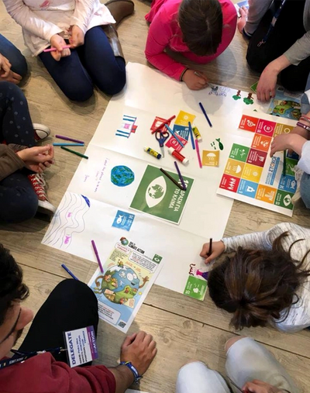

Activity 3: Connecting the Global Goals to Real-Life

In this activity students will explore how they could help achieve the Goals and what that future would look like.
Age 8-13, length - 30 mins

1. Opening discussion
5 mins: Ask students: “How old are you going to be in 2030?” This is the deadline for achieving the SDGs.
Ask students to think individually and then discuss in pairs: “What might you be doing in 2030? What job might you have? What would you like to study? How will you spend your time?”

2. Introduce the Global Goals
5 mins: When they have had time to discuss, ask students to feed back to the group.
Introduce the Global Goals grid (available for download at the bottom of this guide), asking "How do you think we could relate your future life to the Global Goals? What aspects of your future lives would relate to the Global Goals?" Eg. if students wanted to be a teacher that would help to achieve Goal 4. If they wanted to become an engineer that could related to Goal 11.

3. Designing a Global Goals country
10 mins: Explain to students that you are going to design a Global Goals country. Each group will draw their own vision of what a country would look like in 2030 if the Goals are achieved. Ask the class to discuss in their groups “What will your country need to look after its population, environment and natural resources? E.g schools, hospitals, water sources, waste management systems, safe roads."
Give students a large piece of paper to design their country. Ensure each group has a Global Goals grid so students can design a country that has the facilities and infrastructure needed to achieve each Goal. If you have multiple groups, you can combine these countries into a continent!

4. Feedback and discussion
10 mins: After groups have spent some time working on their designs, bring students back together. Give them time to present their country to the rest of the group and then invite students to offer feedback.
Think about what Goals have been achieved, and what might have been missed. For example:
- What in their Global Goals country promotes health and well-being?
- How will they make sure that they are designing a country where everyone is included?
- How will they ensure that nature is protected?
Remember this is not easy and there is no perfect answer! Encourage students to ask questions and reflect on what they’ve done well as well as the improvements they could make.
You can give students some time to update their countries and make improvements. Then it’s time to display and celebrate their work! If you have multiple countries you can then join them together to make a continent, or even a whole planet!

Download the Global Goals grid here​
​
​

