Good Health & Well-being

Introduction to Goal 3 - Good Health & Well-being

Use this guide to introduce Global Goal 3, Good Health & Well-being to your students.
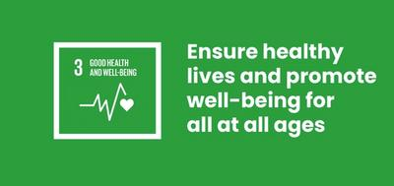

What is Global Goal 3?
Sustainable Development Goal 3: Good Health and Well-being is one of the 17 Sustainable Development Goals established by the United Nations in 2015. You can find out more about the Goals in our introductory guide.
SDG 3 is a broad and ambitious Goal. It aims to achieve access to healthcare for everyone, everywhere. It aims to help people live more healthy lifestyles - for example eating more healthily and exercising regularly - and make the world we live in safer - for example by reducing air pollution and controlling disease outbreaks. It prioritises both physical and mental health.

Activities
Below are some ideas to help bring Goal 3 to life for your students. They work as standalone activities or in sequence as a full lesson plan.

Activity 1: Well-being in the pandemic

In this activity students will discuss health and well-being during the COVID-19 pandemic.
Length - 10 mins
Show your students the following clip about health and well-being during the COVID-19 pandemic taken from 'World's Largest Lesson Live!' and then hold a class discussion.
https://www.youtube.com/watch?v=woqJEoJNDs4
Ask students to reflect on what they’ve just watched:
- How does the conversation relate to your own life?
- What was most interesting?
- How did it make you feel?
Invite students to feedback and discuss on their own experiences of the pandemic.

Activity 2: Understanding Goal 3

In this activity students will explore and discuss why health and well-being is important and what is needed to achieve Goal 3.
Length - 10 mins

1. Introduction
Explain that you’re going to discuss Global Goal 3: Good Health and Well-being - not just COVID-19 but everything that affects our own and other peoples health and well-being.
Display the Goal 3 logo above, explain what Goal 3 is and discuss the following questions:
- What is good health? What is well-being?
- Can you think of examples of physical or mental illness that you have suffered from? What about other people?
- Why is it important to have good health and well-being?

2. Group discussion
Now ask students to imagine a world where Global Goal 3: Good Health and Well-Being has been achieved. Together or in smaller groups discuss the question:
“Think about the future. What would a world where everyone’s health and well-being is cared for look like?”
You might also want to consider these questions in your discussion:
- How does health and well-being affect society? Think about the COVID-19 pandemic in particular? What does society need in place to ensure everyone is looked after?
- What things affect and support health and wellbeing in your community? Eg. hospitals, community centres, parks, green spaces.
- Who is responsible for our health and well-being?

3. Feedback
Give students time to feed back some of their answers. Try to cover as many different ideas and factors as possible - across all the areas covered by Goal 3.
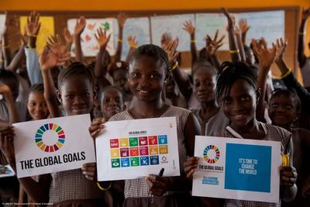

Activity 3: Personal health and well-being goals

In this activity students will make a personal health and well-being plan.
Length - 15 min

1. Introduction
Explain to students that everyone is going to make a personal health and well-being plan, with goals to improve your physical and mental health. Some examples might include: Exercise regularly; Spend quality time with family; Brush teeth twice a day; Get 8 hours of sleep every night.
Encourage students to think for themselves - this is their own personal plan and they do not have to share it if they don’t want. It should be things that they want to achieve for themselves, so that they can be healthier and happier.

2. Writing health and well-being goals
You might want to write each goal using the SMART formula below. Following this structure can improve your chances of achieving your personal goals.
- Specific: What specifically are you trying to accomplish?
- Measurable: How will you know you are making progress?
- Attainable: Can you actually realistically reach this goal?
- Relevant: Is it something that will make a difference to you personally?
- Timely: When do you plan to reach your goal?

3. Feedback and discussion
Ask for volunteers to share one or more of their personal goals.
- Do others share similar goals?
- Can you think of tips to achieve these goals?
- Are there things that might prevent you from achieving them?
Students can display their personal health and well-being plan somewhere in their home. Remind them to check back on their targets to see how they have done.
This activity provides a good introduction to the micro:bit prototyping activities Calming LEDs and Send a smile.

